Wireshark Lab 1: TCP

Group Details:
Zhaoning Kong 1004654288
Qianhao Zhang 1004654377

Mark:

 | Question | Answer
1 | What is the IP address and TCP port number used by the client computer (source) that is transferring the file to gaia.cs.umass.edu? | 192.168.1.102  Port number: 1161  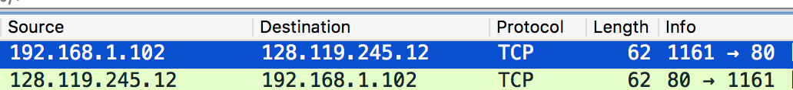
2 | What is the IP address of gaia.cs.umass.edu? On what port number is it sending  and receiving TCP segments for this connection? | 128.119.245.12  Port number: 80
3 | What is the IP address and TCP port number used by your client computer  (source) to transfer the file to gaia.cs.umass.edu? | Souce IP: 100.64.203.116  Source Port: 49461  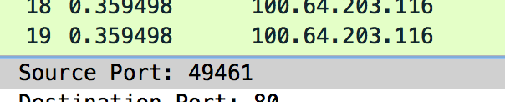
4 | What is the sequence number of the TCP SYN segment that is used to initiate the TCP connection between the client computer and gaia.cs.umass.edu? What is it  in the segment that identifies the segment as a SYN segment? | Sequence Number: 555386525  The SYN flag is set to 1.  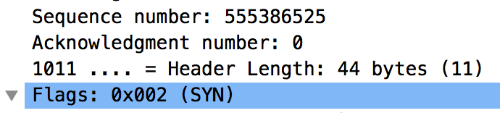  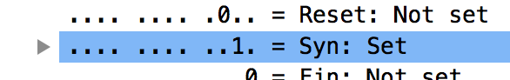
5 | What is the sequence number of the SYNACK segment sent by gaia.cs.umass.edu to the client computer in reply to the SYN? What is the value of the ACKnowledgement field in the SYNACK segment? How did gaia.cs.umass.edu determine that value? What is it in the segment that identifies the segment as a  SYNACK segment? | Sequence number: 2787860960  ACK number: 555386526  For the SYN-ACK packets, the sequence number is always set to the sequence number of SYN-packet plus 1.  Both SYN and ACK flags are set to 1.  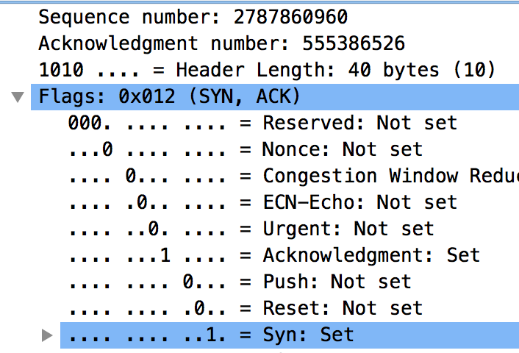
6 | What is the sequence number of the TCP segment containing the HTTP POST command? | Sequence number: 555386526  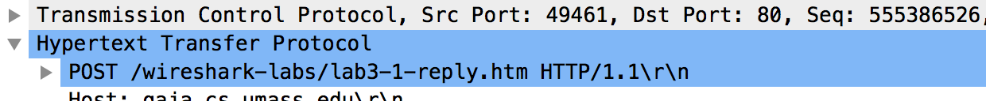
7 | Consider the TCP segment containing the HTTP POST as the first segment in the TCP connection. What are the sequence numbers of the first six segments in the TCP connection (including the segment containing the HTTP POST)? At what time was each segment sent? When was the ACK for each segment received?  Given the difference between when each TCP segment was sent, and when its acknowledgement was received, what is the RTT value for each of the six segments? What is the EstimatedRTT value after the  receipt of each ACK? | Sequence number: 555386526, 555387132, 555387269, 555388673, 555390077, 555391481  Time sent:  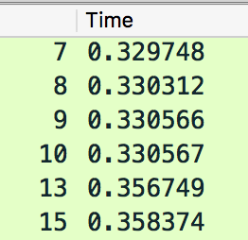  Receive at: 0.356657, 0.356662, 0.358324, 0.359451, 0.383415, 0.385476  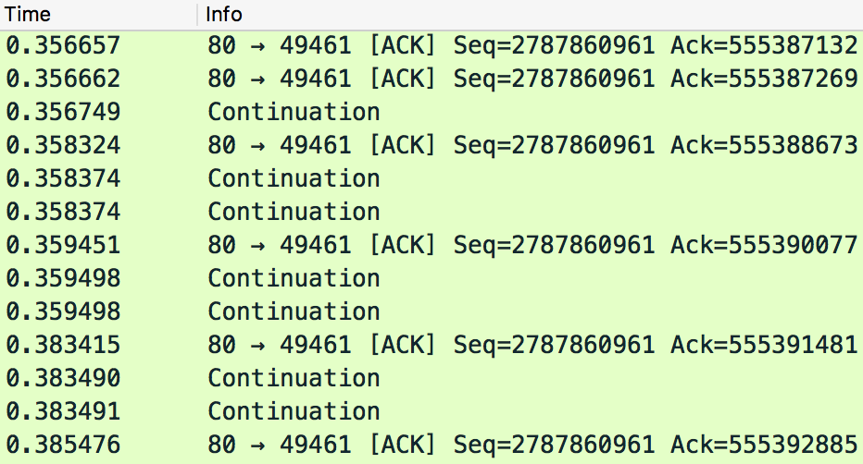  RTT: 0.026909, 0.02635 , 0.027758, 0.028884, 0.026666, 0.027102  Estimated RTT after each receipt: 0.026909, 0.026839, 0.026953, 0.027195, 0.027129, 0.027125
8 | What is the length of each of the first six TCP segments? | 606, 137, 1404, 1404, 1404, 1404
9 | What is the minimum amount of available buffer space advertised at the received  for the entire trace? Does the lack of receiver buffer space ever throttle the sender? | Minimal advertised window size: 28960  The lack of receiver buffer did not throttle the sender.  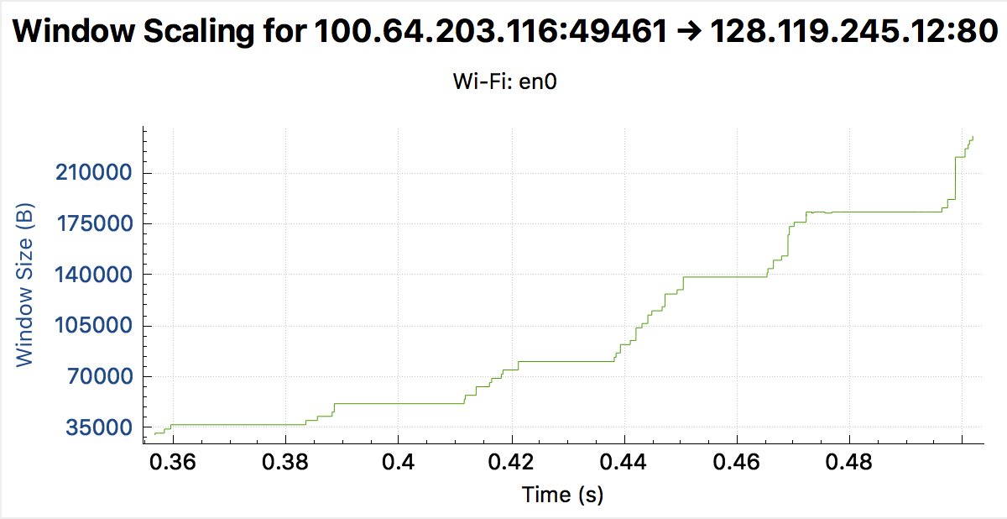
10 | Are there any retransmitted segments in the trace file? What did you check for (in the trace) in order to answer this question? | Yes. The first (SYN) packet is being retransmitted, because they have the same sequence number.
11 | How much data does the receiver typically acknowledge in an ACK? Can you identify cases where the receiver is ACKing every other received segment | 1404 or 2808 bytes.  Typically, one HTTP frame should be of size 1404 bytes. Upon the arrival of in-order segment with expected sequence number, and all data up to expected sequence number already acknowledged, TCP sends ACK for every other packet. If one other in-order segment waiting for ACK transmission, TCP immediately send single cumulative ACK for both in-order segments.  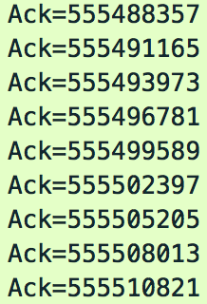
12 | What is the throughput (bytes transferred per unit time) for the TCP connection?  Explain how you calculated this value. | We calculated throughput by dividing the size of the file by the time it takes to be transmitted by TCP, which can be deduced from the traces. We calculate the number of bytes transmitted by taking the relative ACK number of the last packet.  149329 * 8 / 0.501845 = 2380911 (bit/s)
13 | Use the Time-Sequence-Graph (Stevens) plotting tool to view the sequence number versus time plot of segments being sent from the client to the gaia.cs.umass.edu server. Can you identify where TCP’s slowstart phase begins and ends, and where congestion avoidance takes over? Comment on ways in which the measured data differs from the idealized behavior of TCP that we’ve studied in the text. | In the first few hundred milliseconds, TCP is in slow start state, and then enters congestion avoidance. After that, the rate is constant, sending 6 packets each time, which differs from what we’ve studied, which is different from the linearly increasing rate as described in the textbook.  This is probably enforced by HTTP server.  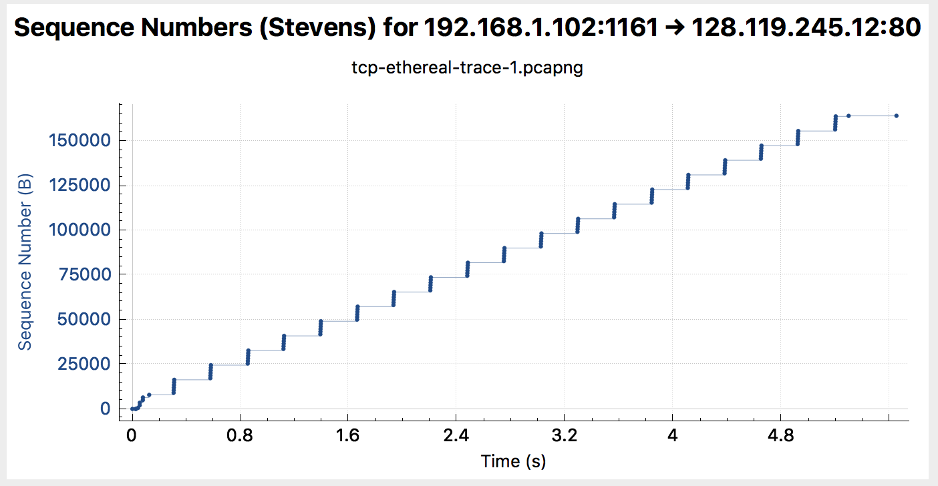
14 | Answer each of two questions above for the trace that you have gathered when you transferred a file from your computer to gaia.cs.umass.edu | The TCP remains in slow start state during the entire transmission. This is what we expected.  